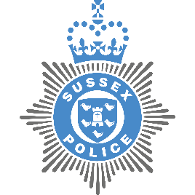 |  | 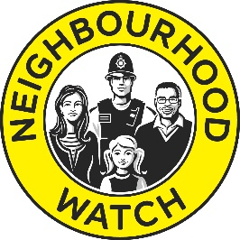

Sussex Neighbourhood Watch Co-ordinator/Street Contact
Registration & Security Consent form

Neighbourhood Watch Co-ordinators/Street Contacts are volunteers in a position of authority and trust. Sussex Police and Neighbourhood Watch have a policy of checking all Co-ordinators/Street Contacts and deputies to verify their identity, and for any previous convictions or other circumstances that would make it inappropriate for them to hold such a position. Any information given will remain confidential. Not all previous convictions will mean automatic disqualification, but the final decision will rest with Sussex Police. You will need to submit a copy of your passport or driving licence, or other official documentation to establish your identity, along with this form.

Please complete in BLOCK CAPITALS the details below.

Title and full name:

Previous surnames used (if applicable):

Date of birth: Place of birth:

Home address:

Postcode:

Home phone: Mobile:

E-mail address:

My scheme covers:

I give permission for Sussex Police to perform all necessary background checks. I also give Sussex Police and Neighbourhood Watch authority to place my details on file, in compliance with Data Protection laws, and to use them for policing and Neighbourhood Watch purposes only. I agree to comply with Data Protection laws, and to relinquish my position should circumstances arise or information become available that would be inconsistent with my holding this position of responsibility. I agree to receive community messages from Sussex Police, Action Fraud and Neighbourhood Watch, and where appropriate to forward these to Neighbourhood Watch members in my scheme.

Signed: Date:

For NHW identity document checking co-ordinator use only
Sign here if originals have been verified:

For Sussex Police use only
PNC: | Niche/local information:
Checked by: | Checked at: | Date:

